(Title of work) Everything Begins With One Sentence.

(Name of team) SUAE teammates
(Name) Hankook KIM
(University) Department of Architecture, Pusan National University, Busan, Korea
(Name) Hankook KIM
(University) Department of Architecture, Pusan National University, Busan, Korea
(Name) Hankook KIM
(University) Department of Architecture, Pusan National University, Busan, Korea

PROLOGUE
At the end of our winter workshop, I was informed that, at the time of seeing, listening to and recording the participants’ research results, photographs and interview materials, an exhibition about drawings and some quotes from John Berger(1926-2017)’s own books was being held at a small gallery in Seoul. The exhibition titled "John Berger's Sketchbook" was presented at On Ground Gallery for a month from March 9th to April 7th, 2017. I thought I would like to see his last work, "Confabulations" (2016) and this exhibition which was set up to commemorate him in a small gallery in Seoul. Actually it looks like that there is no correlation between listening to their interview voices and going to the gallery on the surface.
However I got to know. I have learned that the voices of all the participants from the three countries I had met were similar to that of John Berger as an aspect of attitude to life. So, at that time I wanted to record and share these interviews with them and his sentences side by side. At first, that is why the subtitle of prologue is “How to Resist a State of Forgetfulness”, which is his last essay’s title and what we realized after we finished the workshop.

And so what is being publicly said and the way it is being said promotes a kind of civic and historic amnesia. Experience is being wiped out. The horizons of past and future are being blurred. We are being conditioned to live an endless and uncertain present, reduced to being citizens in a state of forgetfulness.
Meanwhile, around us, the planet is overheating. The wealth of the planet is being concentrated in fewer and fewer hands; the majority are underfed, junk-fed or starving. More and more millions of people are being forced to emigrate with the slimmest hopes of survival. Working conditions are becoming more and more inhuman.
Those who are ready to protest against, and resist, what is happening today are legion, but the political means for doing so are for the moment unclear or absent. They need time to develop. So we have to wait. But how to wait in such circumstances? How to wait in this state of forgetfulness?

Berger, John. Confabulations (pp. 139-143). Penguin Books Ltd. Kindle Edition.

The aim of the workshop was to explore and document the elements and patterns of a city, Busan in order to resist a state of forgetfulness in response to rapid urbanization and economic development in our Asian cities for building sustainable urban and architectural environment of cities ultimately.

outline of Interview
This 2017 Winter Workshop Busan, held in Pusan ​​National University from February 1 to 28, 2017, was the first official student exchange program of SUAE Asia programs among three countries. The participants from three countries had an opportunity to interact with the foreign students and professors aside from presenting and sharing research results.

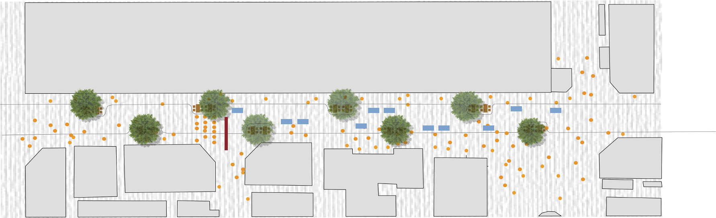
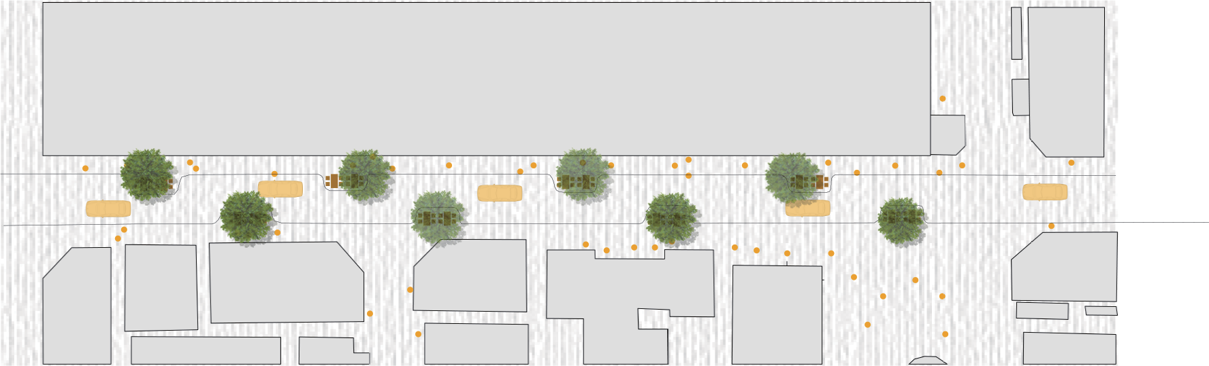
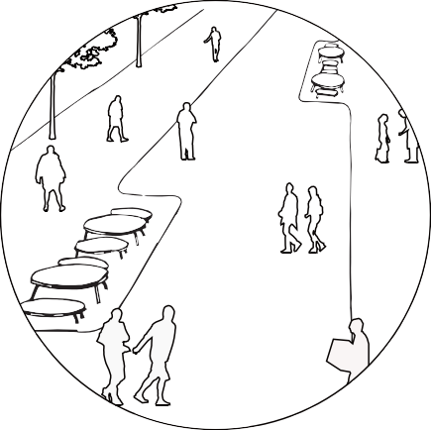
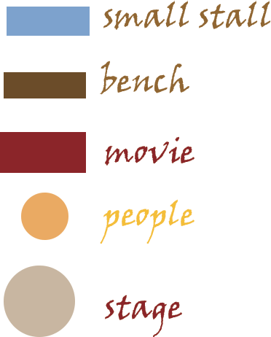
Fig.1 Plan of cafe street after implementation (car-allowded time)
Fig.2 Plan of cafe street after implementation (no car time)

Reference

[1] The Public Life Diversity Toolkit, Gehl,6
[2] A City for Everyone: Draft Inclusive Brisbane Plan 2019-2029

( 10 pages including all contents of work result )

John Peter Berger (5 November 1926 – 2 January 2017) was an English art critic, novelist, painter and poet. His novel G. won the 1972 Booker Prize, and his essay on art criticism, Ways of Seeing, written as an accompaniment to a BBC series, is often used as a university text. He lived in France for more than half a century. John Peter Berger (5 November 1926 – 2 January 2017) was an English art critic, novelist, painter and poet. His novel G. won the 1972 Booker Prize, and his essay on art criticism, Ways of Seeing, written as an accompaniment to a BBC series, is often used as a university text. He lived in France for more than half a century. (source: Wikimedia Commons)

